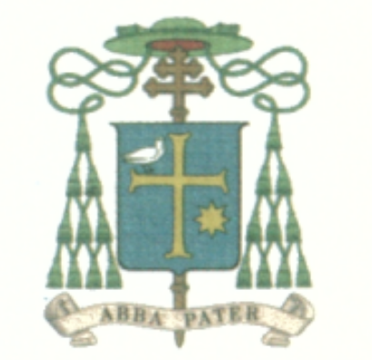
Mons. Domenico Sorrentino
Vescovo di Assisi-Nocera Umbra-Gualdo Tadino
Piazza Vescovado 3 – 06081 Assisi (PG)
Tel 075 812393 – 3347560145
vescovo@domenicosrt.it
Assisi, 18 September 2016

To the representatives of Christian confessions and of various religions
attending the interreligious assembly for peace among peoples
- on the occasion of the 30th anniversary of the Spirit of Assisi
Assisi 18 – 20 September 2016

Dear friends,

In the name of the Church, which I have the honor to serve, I welcome you wholeheartedly.
What S. John Paul II did here in Assisi thirty years ago was really prophetic. Unfortunately our world is still under the weight of violence, and is now experiencing, as our Pope Francis has said, a world war fought in “pieces”. We must become more conscious of our responsibility as believers, regardless of our particular religious beliefs. We know that God, no matter what name we call Him in our different religious traditions, is Love and the source of Love.

This must be a common conviction among all of us, who consider ourselves to be believers. I am very happy that we will have these days together to reaffirm this important truth.

My predecessor, Bishop Guido, eight centuries ago welcomed the young Francis, when he came to him to be judged under the accusation of his father. In front of the Bishop and the others present, Francis stripped himself of all his garments. He wanted to be naked like Christ crucified, to become a new man, clothed only in love for all the people and creatures of the world.

Three years ago, Pope Francis, speaking in my house, in the room of the disrobing of Saint Francis, remarked that every Christian must strip himself of the spirit of the world – the spirit of egoism and of evil – in order to put on the spirit of God. This means the spirit of love, of peace, of benevolence, of service. Only if we are clothed with this spirit, can we really be builders and witnesses of peace.

Please, accept this little book that I wrote, entitled “Accomplices of the Spirit”, where I asked myself what would I have done if I had been in the place of my predecessor who did not hesitate to take the side of Francis. The Bishop and Francis became “Accomplices of the Spirit of God”, to build a new world. Without that great alliance of a man of the Church and of a young charismatic, we probably would not be here today in Assisi, in the footsteps of Saint Francis, continuing his effort to build a peaceful world.

Let us pray for each other and for our communities.
I give you my warmest greetings and I look forward to meeting you personally during the days to come. May God bless you.

